

**Department of Electrical and Computer Engineering**

| Course Number | CPS510 |
| --- | --- |
| Course Title | Database Systems I |
| Semester/Year | F2022 |
| Instructor | Dr. S. B. Tajali |
| Lab Section | 7 |

| Assignment No. | 3 |
| --- | --- |
| Assignment Title | Assignment 3: Schema Design |

| Submission Date: | September 12, 2022 |
| --- | --- |
| Due Date: | September 12, 2022 |

| Student Name | Ethan Moo-Young | Ernestine Ho | Abel Abraham Thomas |
| --- | --- | --- | --- |
| Student ID | 501016708 | 501022253 | 501029194 |
| Signature |  |  |  |

**[Book] Table**

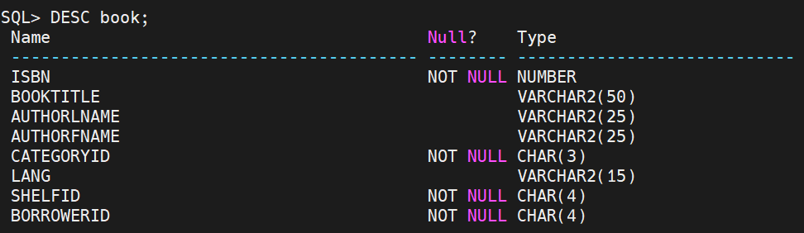

| CREATE TABLE book(  ISBN NUMBER PRIMARY KEY,  BookTitle VARCHAR2(50) DEFAULT ‘Book Title’,  AuthorLname VARCHAR2(25) DEFAULT ‘Last Name’,  AuthorFname VARCHAR(25) DEFAULT ‘First Name’,  CategoryId CHAR(3) NOT NULL REFERENCES category(CategoryId),  Lang VARCHAR2(15) DEFAULT ‘English’,  ShelfId CHAR(3) NOT NULL REFERENCES shelf(ShelfId),  BorrowerId CHAR(4) NOT NULL REFERENCES client(ClientId)  ); |
| --- |

The [Book] Table entity contains a catalogue of books. Each book includes a unique ISBN identifier as the primary key. The attributes, ‘CategoryId’, ‘ShelfId’ and ‘BorrowerId’ reference other primary keys from other tables and are thus designated as NOT NULL

**[Client] Table**

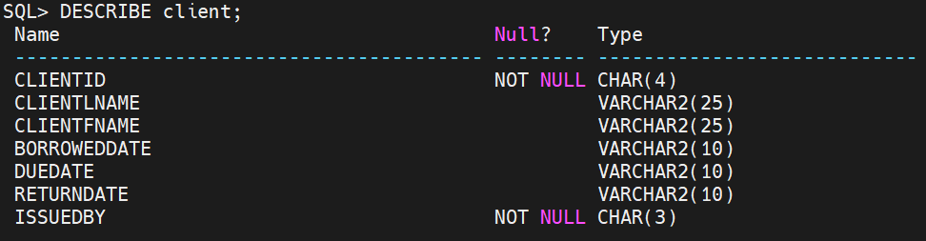

| CREATE TABLE client (  ClientId CHAR(4) PRIMARY KEY,  ClientLname VARCHAR2(25) DEFAULT ‘Last Name’,  ClientFname VARCHAR2(25) DEFAULT ‘First Name’,  BorrowedDate VARCHAR2(10) DEFAULT ‘dd/mm/yyyy/’,  DueDate VARCHAR2(10) DEFAULT ‘dd/mm/yyyy’,  ReturnDate VARCHAR2(10) DEFAULT ‘dd/mm/yyyy’,  IssuedBy CHAR(3) REFERENCES staff(StaffId)  ); |
| --- |

The [Client] Table describes a list of clients associated with the library, its primary key is the ‘ClientId’ attribute. Each client is issued books via a staff member; hence, the ‘IssuedBy’ attribute references the [Staff] table’s ‘StaffId’.

**[Shelf] table**

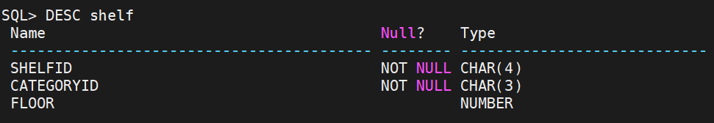

| CREATE TABLE shelf (  ShelfId CHAR(4) PRIMARY KEY,  CategoryId CHAR(4) REFERENCES category(CategoryId),  FLOOR NUMBER  ); |
| --- |

The [Shelf] Table denotes the specific shelf location and which category it belongs to. The primary key is the ‘ShelfId’ and the ‘CategoryId’ references the [Category] table.

**[Category] Table**

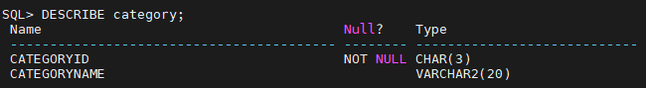

| CREATE TABLE category (  CategoryId CHAR(3) PRIMARY KEY,  CategoryName VARCHAR2(20)  ); |
| --- |

The [Category] Table describes various categories/genres of book. It is mainly used to organize shelves and books under certain specifications. Its primary key is a specific ‘CategoryId’.

**[Staff] Table**

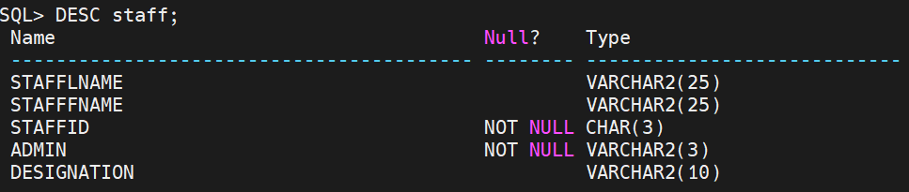

| CREATE TABLE staff (  StaffLName VARCHAR2(25) DEFAULT ‘Last Name’,  StaffFName VARCHAR2(25) DEFAULT ‘First Name’,  StaffId CHAR(3) PRIMARY KEY,  Admin VARCHAR2(3) UNIQUE NOT NULL,  Designation VARCHAR2(10)  ); |
| --- |

The [Staff] Table describes employees and other staff currently employed by the library. Each Staff has a specific ID as their primary key. Certain staff can also be designated as administrators through the ‘Admin’ attribute as a unique candidate key.